Soldering Wires Together

Green = Useful

ATL Link
This source shows thinking and research. I am pushing forward and finding different techniques and methods of construction that can be used for the various parts of my product. In this case, it is to join the wires that will be used in my lighting

Link to Criteria
“To research and source the selected materials from local suppliers”

Global Context
Solder is a material used in all types of constructions globally such as metalwork, plumbing and electronics. Different types of solder have been developed for many different applications each with a different chemical composition to suit the needs of a specific task.

Learner Profile link
Inquirers
Open-Minded

Why did I select this resource?
This resource was an easy to follow explanation that was excellent for explaining how to join the wires in a durable join that would last the test of time.

How can I apply this information?
This information will help me in the construction process of my product as I will be able to use this construction technique when creating the lighting for my structure.

Bibliography
Golond, ~. 2016, 'Soldering Wires Together', Instructables [Online] Available http://www.instructables.com/id/Soldering-wires-together/?ALLSTEPS, Accessed21 January 2017.
Soldering Wires Together

When splicing wires together, it is important to get an electrical connection that will keep conducting even after your soldering iron has cooled off. Paramount to this is getting a good mechanical connection between the wires, not just an electrical one.

Step 1: Prepare your wires

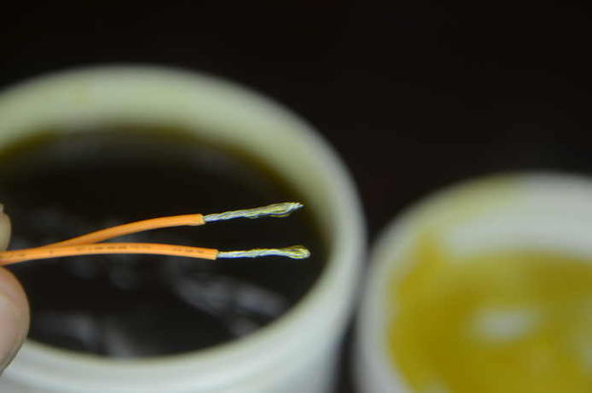

Freshly stripped multi-filament wires need some attention before they will take well to being soldered.
First, the filaments of each wire should be twisted together, or pigtailed, to keep them orderly and behave more like a single entity.
I prefer to add some soldering resin to the filaments at this point too. It really helps the solder flow when tinning the wires. If using flux core solder, this step isn't critical, but it still does help.

Step 2: Tin your wires

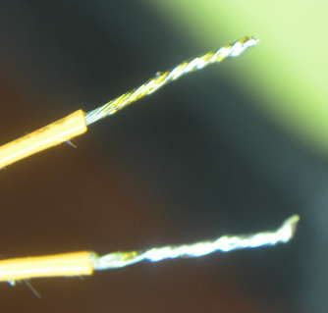

Tinning the wires, melting some solder into the filaments with your soldering iron before joining them will make the next step of soldering of the splice much easier. It helps distribute the heat quickly, and the pieces require heat for a much shorter time, since you don't have to spread as much solder around later. This reduces the likelihood that you'll melt through the wire shielding near the splice, or damage nearby components if soldering to a circuit board or to a component itself.
You want even distribution of the solder between the filaments, but not so much that the solder starts to swallow the filaments. The top wire in the picture is just about right, but the bottom one has too much solder. Too much solder will make the wires quite stiff, and they still need to be fairly pliable for the next step.

Step 3: Mechanically join your wires

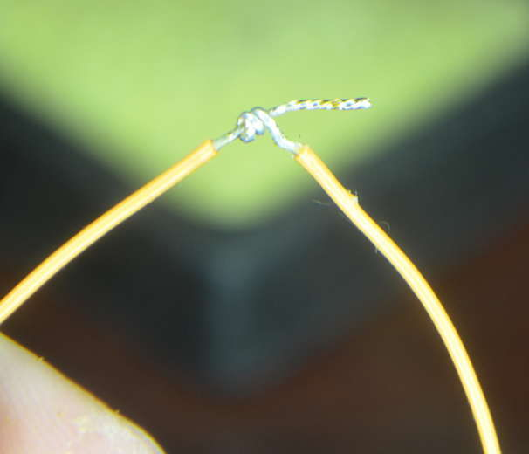

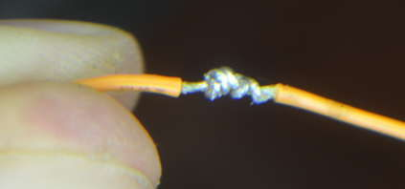

In order to resist being pulled apart, the wires should be wrapped around each other before the soldering takes place. This will make it so that if the wires are pulled on it isn't the solder holding things together. Solder's primary function is conducting electricity, not gluing things together (though it certainly does help with that too).
Wrap one wire around the other, taking care to leave enough metal exposed above the sheath so the other wire can be wrapped around it in turn. The turns of the wrap should sit next to each other and not overlap. Keep your wraps tidy.

Step 4: Solder the splice together

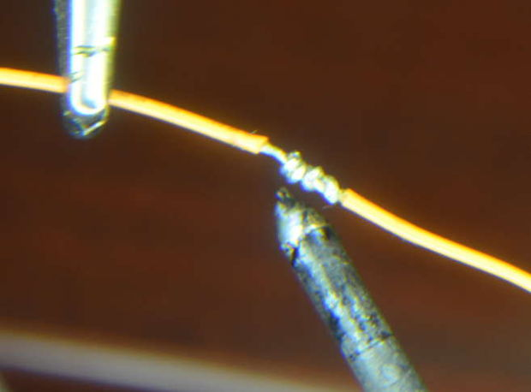

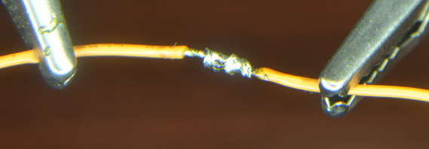

Now that the two tinned wires are wrapped around each other, we can re-apply the soldering iron and the solder from each wire will melt and mingle, forming a nice solid solder joint. It will be necessary to add a little more solder to really fill in the cracks and get a high strength, low resistance joint.

